Solve the Problem

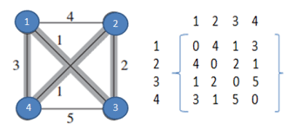
g(1,{2,3,4})=min{c₁₂+g(2,{3,4}),c₁₃+g(3,{2,4}),c₁₄+g(4,{2,3})}
g (2,{3,4}) = min { c₂₃ + g(3,{4}) , c₂₄ + g(4,{3}) }
g (3,{4})=c₃₄+c₄₁=5+3=8
g (4,{3})=c₄₃+c₃₁=5+1=6
g(2,{3,4})=min { c₂₃+8,c₂₄+6}=min{2+8,1+6}=min{10,7}=7
g(3,{2,4}) = min { c₃₂ + g{2,{4}, c₃₄ + g(4,{2} ) }
g (2,{4})= c₂₄ + c₄₁=1+3=4
g (4,{2}) = c₄₂ + c₂₁=1+4=5
g(3,{2,4}) = min { c₃₂ + 4, c₃₄ + 5 }=min{2+4,5+5}
= min {6, 10} = 6
g (4,{2,3})= min { c₄₂ + g{2,{3}, c₄₃ + g(3,{2}) }
g {2,{3}= c₂₃ + c₃₁=2+1=3
g(3,{2})= c₃₂+c₂₁=2+4=6
g (4,{2,3})= min { c₄₂ + 3, c₄₃ + 6 }
=min {1+3, 5+6} = min {4, 11} = 4
g (1,{2,3,4})=min {c₁₂+7,c₁₃+6,c₁₄+4}
=min {4+7, 1+6, 3+4}
= min {11, 7, 7} = 7
1, 3, 2, 4, 1=Optimal Path
Length=1+2+1+3=7
Optimal path length=7

